Access Report Examples
WPH Office of Academic Computing

Below you will find some examples of existing Access reports that are programmed by the OAC and used across various studies. If you would like to incorporate any of the below into the Access reporting portion of your study, please make a note of the report name in Question 11 within the ‘Database Requirements, Access Components and Reporting – Project Specifications Worksheet’ document.

I. Progress Reports
- Number Screened
This report is often broken down by demographics and is pulled from a Screening Table
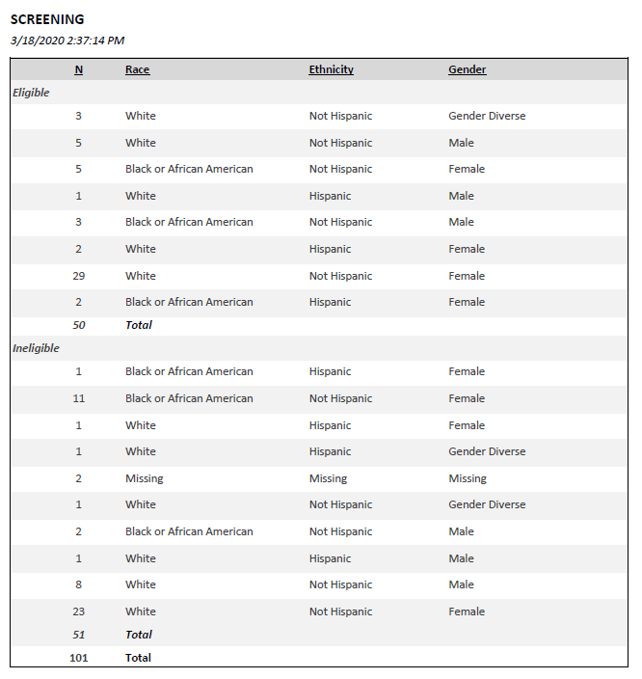
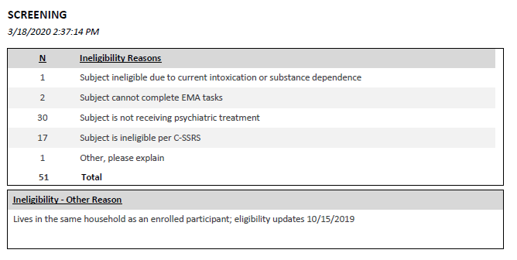
- Number Eligible
This report is often broken down by demographics and reasons for ineligibility and is pulled from a Screening Table

- Number Enrolled
This report is often broken down by demographics. For purposes of reporting, it is important to determine when a participant considered to be enrolled (when a study ID is given, a demographic form is completed, a record in a consent table, etc.)
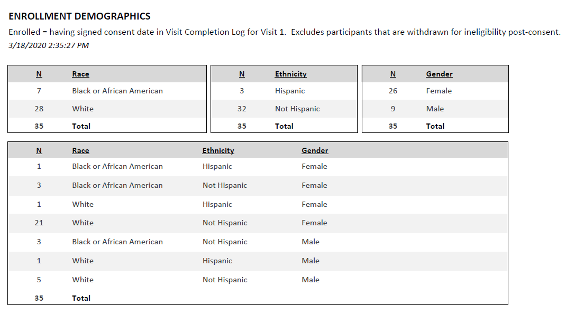
- Number Withdrawn
This report is often broken down by reasons withdrawn and is pulled from a Withdrawn table (foreign key for withdrawn reasons)

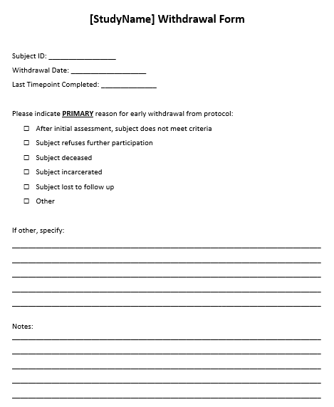

- Number of Timepoints Completed
This report captures the number of participants that have completed each timepoint and is pulled from a Timepoint Complete table. If compensation for study participants is determined at the timepoint level, a checklist that logs payments per component complete can be programmed to track completed timepoints and payments in one table
II. Tracking Reports
- Contacts with Participants
This report captures a history log of contacts with each participant and corresponding notes and is pulled from an Entry form (that includes FK. ContactReason). The Entry form can be used to track scheduled appts as well.

- Participant Due Dates
This report lists IDs that are due (often within 2 weeks) or are overdue for a follow-up visit. Participants who are due per study follow-up design (usually calculated in a view), but do not have a record in Timepoint Complete table (see above). Can pull scheduled appts from contact tracking log
